
MATHS METHODS (CAS) 3 & 4
TRIAL EXAMINATION 1
SOLUTIONS
2011

Question 1
- 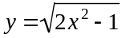
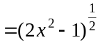

Method 1
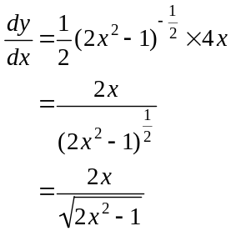
(1 mark)

(1 mark)
Method 2
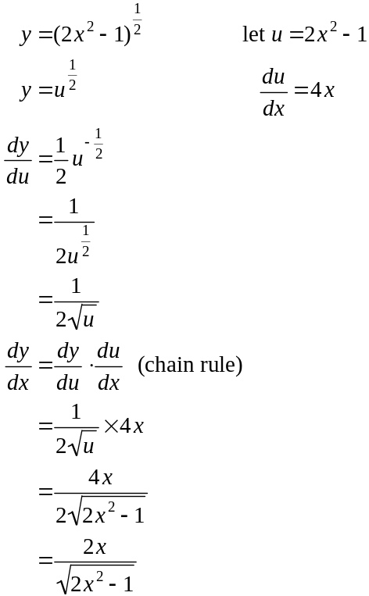
(1 mark)
(1 mark)

b. 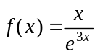
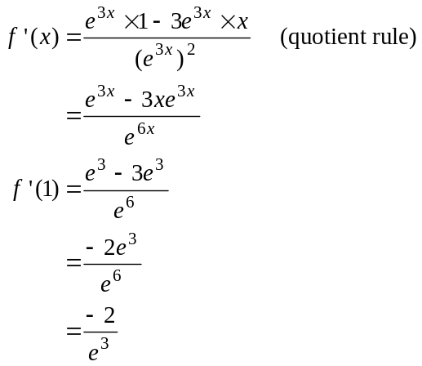
(1 mark)
(1 mark)
Question 2
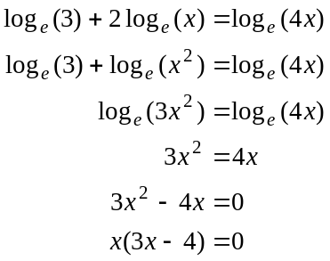
(1 mark)
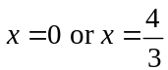 (1 mark)
but 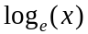 is not defined for so 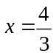
(1 mark)
Question 3
- 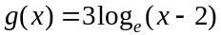
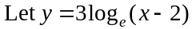
Swap x and y for inverse. (1 mark)
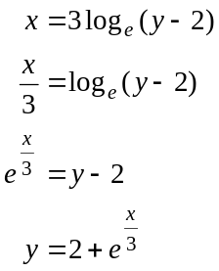
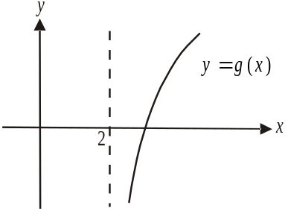
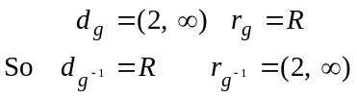
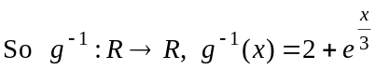 (1 mark) – correct rule
(1 mark) – correct domain
- i. 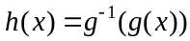
(1 mark)
- 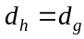 (since h is a composite function)
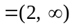 (1 mark)
Question 4

- Note that since variance = 4, standard deviation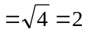.

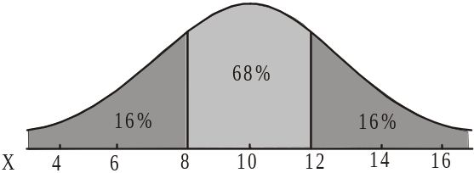
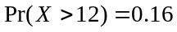

(1 mark)

- 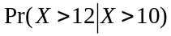
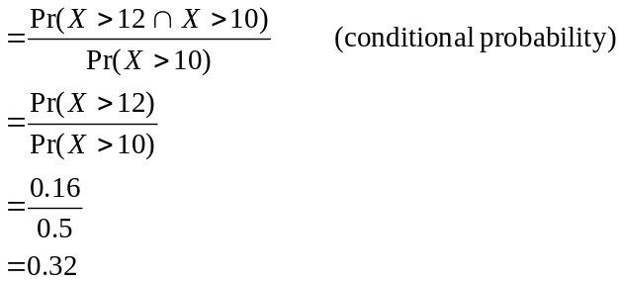
(1 mark)
(1 mark)

- 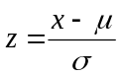
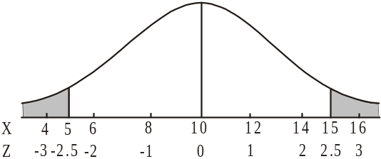
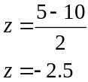

(1 mark)

Because of the symmetry of the normal curve,
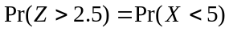
So
(1 mark)
Question 5

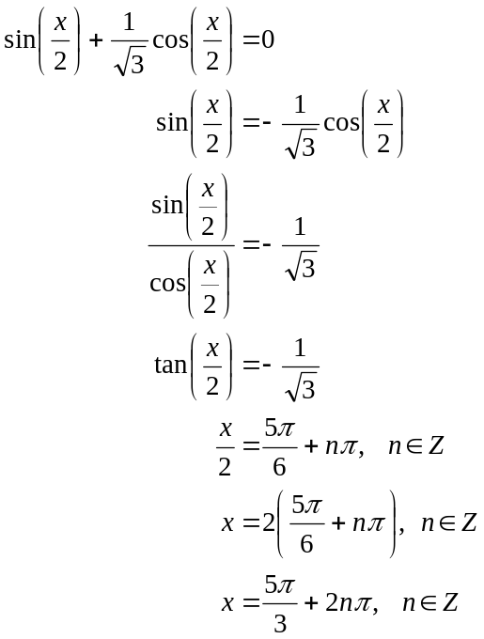
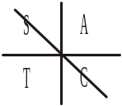
(1 mark)
(1 mark)
(1 mark)
(alternative answer 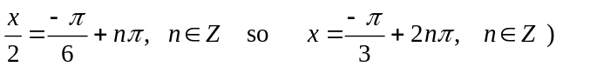

Question 6

- We have a binominal distribution where 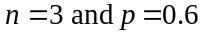.

Method 1

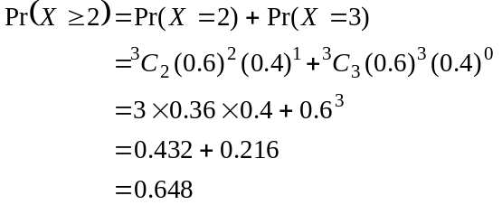
(1 mark) – recognition of binominal distribution
(1 mark) – correct answer

Method 2

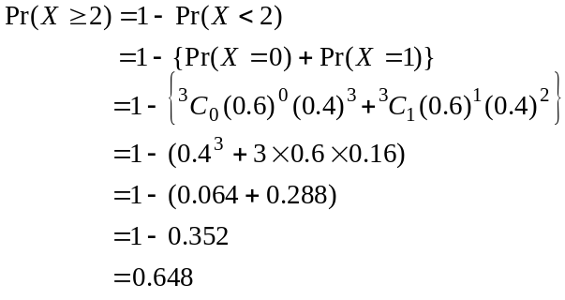
(1 mark) – recognition of binominal distribution
(1 mark) – correct answer
b. Let the number of orders placed at the drive-through be n.

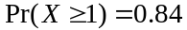
(1 mark)
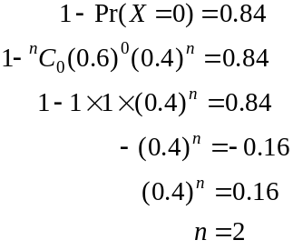
(1 mark)
(1 mark)
Two orders need to be placed.

Question 7

We are looking for 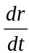, the rate at which the radius of the balloon is changing.

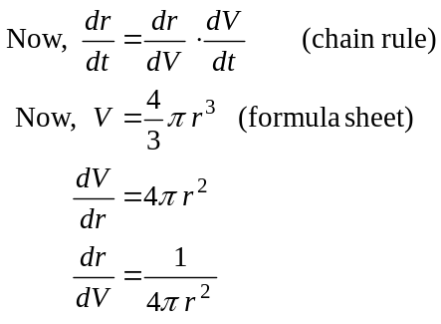
(1 mark)

Also 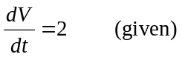
So 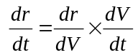
becomes 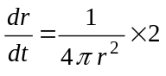
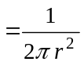
When 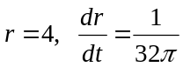
(1 mark)
The radius of the balloon is increasing at the rate of 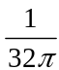 cm/sec.
(1 mark)

Question 8

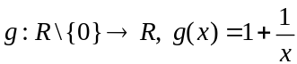
To Show: 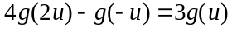

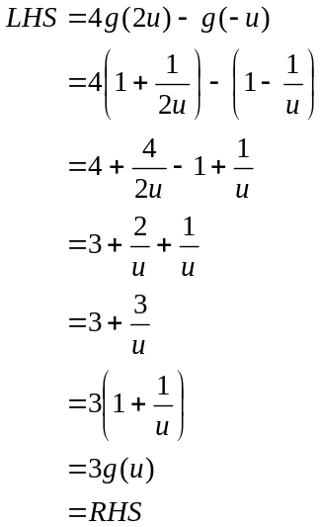
(1 mark)
as required.
(1 mark)

Question 9

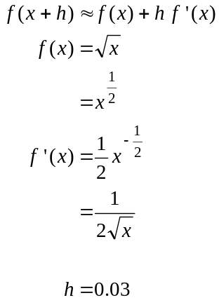
(1 mark)
(1 mark)

So 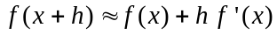
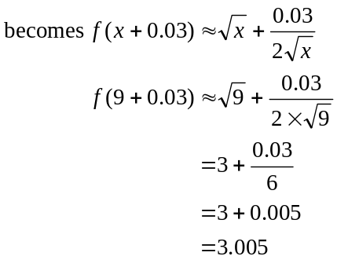
(1 mark)
Question 10

The period of the graph of 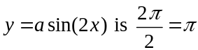 so the graph intersects the x-axis at the right end of the shaded region at 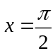.
(1 mark)
So 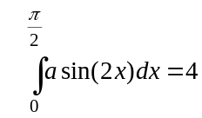
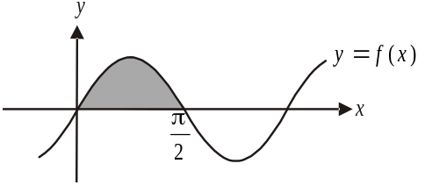
(1 mark)
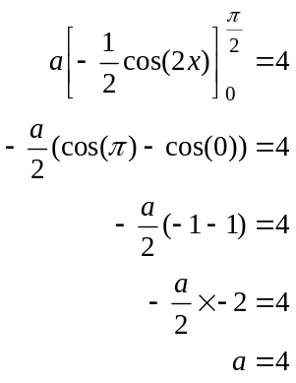
(1 mark)
(1 mark)

Question 11

- Since the graph of 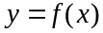 is not smooth at the point where 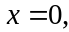 then 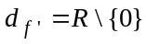.
(1 mark)

- 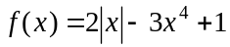

Method 1
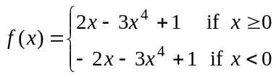
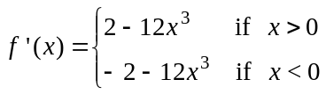
(1 mark)
(1 mark)

Method 2

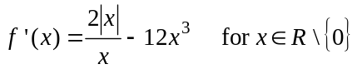
(1 mark) – first term
(1 mark) – second term

